**Project II: Hess-Smith Panel Method and TAFT**

Nathan Holmes

May 7th, 2018

North Carolina State University, Raleigh, NC, 27607

**Nomenclature**

*x/c* nondimensionalized x coordinate

$C_{l}$ coefficient of lift

$C_{p}$ coefficient of pressure

$γ$ source strength, ‘*ss*’ in code

$V_{∞}$ freestream velocity, code run at value of 1

*c* chord, code run at value of 1

${ΔS}_{j}$ distance of panels around the airfoil

$y_{camb}$ camber y-coordinates

$x_{camb}$ camber x-coordinates

1. **Introduction**

The goal of this project was to obtain and compare the CL VS. alpha and CP VS *x/c* graphs from two chosen airfoils as well as the silhouette of a chosen animal using both the Hess-Smith panel method and Thin Airfoil Theory. In this case, the airfoils chosen were the Supermarine 371-I and NASA LRN 1015. As for the animal, a squid was chosen. Much thought was put into this decision, but ultimately a squid was decided upon because squids are cool, and as everyone knows, all squids really want to do is fly.

1. **Airfoil Background**

The Supermarine 371-I airfoil was used at the root of the wings for the British WWII era Supermarine Spitfire, which had an elliptical wing design. There is another Supermarine 371-II airfoil that was used for the tip of the craft’s wings.

Crafts such as the Northrop Grumman RQ-4 Global Hawk use the NASA LRN 1015 airfoil. First produced in 1998, the Global Hawk is still used an unmanned aerial vehicle for surveillance by government agencies.

1. **Methodology**

In addition to the provided code, an initial section for loading in coordinates was included in the script, followed immediately by input variables ALPHA and UINF, with ALPHA in degrees (it is then converted into radians). A new loop was created to vary between the specified angles of attack, -5 to 15 degrees. After the provided panel method code but still within the same angle of attack variance loop, the coefficient of lift for the panel method was calculated using Eq. (1). The negative of coefficient of pressure, CP, is then plotted within the loop and returns figures 4, 8, and 11.

|  |  |  |
| --- | --- | --- |
|  | $$C_{l}=\frac{2γ}{{cV}_{∞}}\sum_{j=1}^{N}{Δ}S_{j}$$ | (1) |

Next, the in the TAFT section, the camber line for the airfoil (or animal) is calculated by averaging the upper and lower Y/C values, which are then used in a loop to calculate the coefficient of lift from TAFT, CLTAFT. This calculation is carried out with the application of Eq. (2). Theta was calculated using trigonometry and the $x_{camb}$ values, as seen in the code.

|  |  |  |
| --- | --- | --- |
|  | $$C_{l}=2π[α-\frac{1}{π}\sum_{i=1}^{N}{\frac{y_{camb}\left(i+1\right)-y_{camb}\left(i\right)}{x_{camb}\left(i+1\right)- x_{camb}\left(i\right)}}[x_{camb}\left(i\right)+x_{camb}\left(i+1\right)][theta\left(i+1\right)-theta\left(i\right)]$$ | (2) |

In the case of the squid, it’s coordinates were obtained through digitization, and its camber line was calculated through the same process as for the airfoils. Only the outline of the squid was used in the calculations, after the removal of some of the material. The image used is represented by Fig.1, while the original image can be seen in Fig. 2.

|  |  |
| --- | --- |
| **Figure 1. Squid image used.** | **Figure 2. Original image.** |

The mean variation in CL, CLVAR, was calculated using the mean of the differences in the CL values for TAFT and the Hess-Smith panel method. These values are used to compare the plots below.

1. **Results**

Three plot types result from the code: a simple image for reference of the airfoil and its camber line, CP VS *x/c*, and CL VS ALPHA. The appear for each airfoil below as listed.

1. **Airfoil 1: Supermarine 371-I (root)**

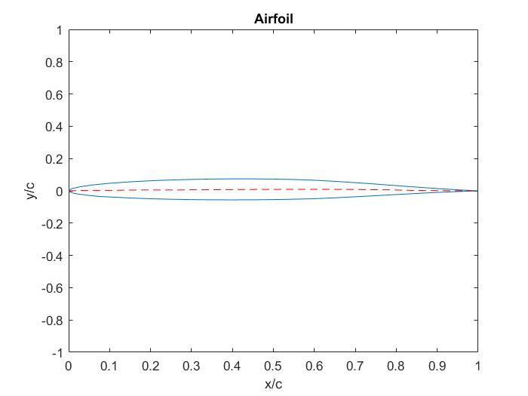

**Figure 3. Supermarine 371-I Airfoil.**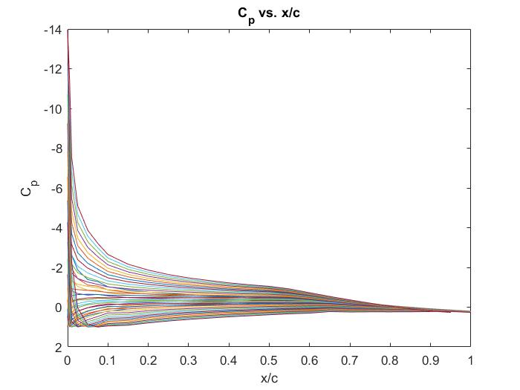

**Figure 4. Supermarine 371-I CP vs. *x/c*.** At angle of attack 15, the maximum CP value was -13.9611.

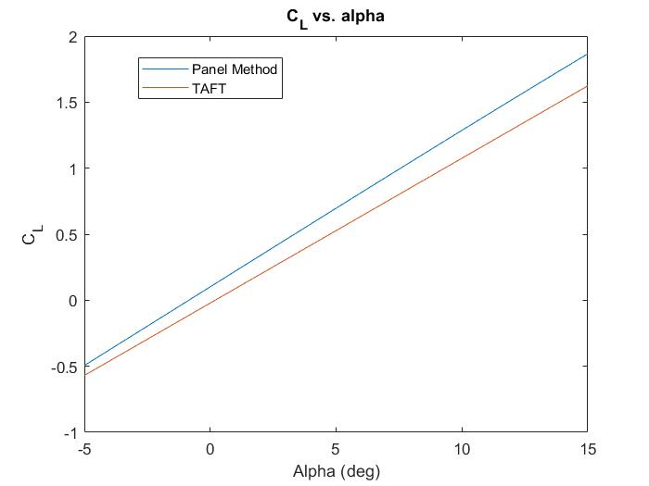

**Figure 5. CL vs. alpha for Supermarine 371-I.** From inspecting the graphs, the panel method shows alpha zero-lift to be approximately -0.9 degrees, while TAFT predicts around 0.2 degrees. Mean CL variation for the difference of the plots is 0.1657.

1. **Airfoil 2: NASA LRN 1015**

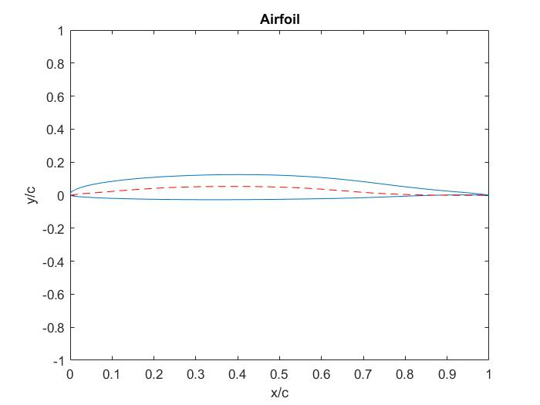

**Figure 7. NASA LRN 1015 Airfoil.**

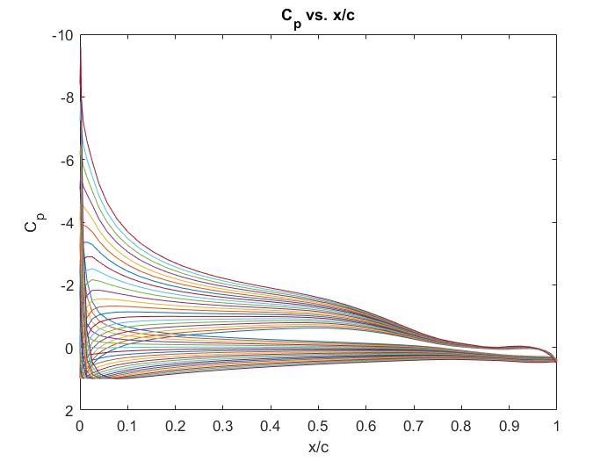

**Figure 8. NASA LRN 1015 CP vs. *x/c*.** Maximum CP of -9.6109 at 15 degrees angle of attack.

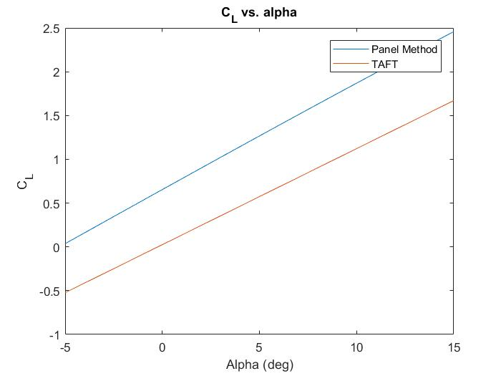

**Figure 9. NASA LRN 1015 CL vs. alpha.** By inspection, the alpha zero-lift for the airfoil as predicted by TAFT is around -0.25 degrees. The panel method prediction sits around -5 degrees for this value. The plots had an average variation of 0.9778 in their CL values.

1. **Squid (creature)**

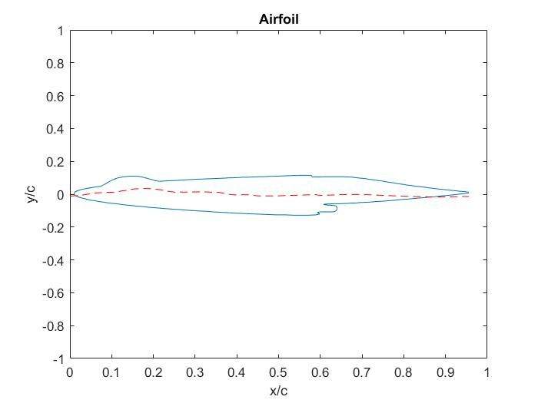

**Figure 10. When Squids Fly (Squid Airfoil).**

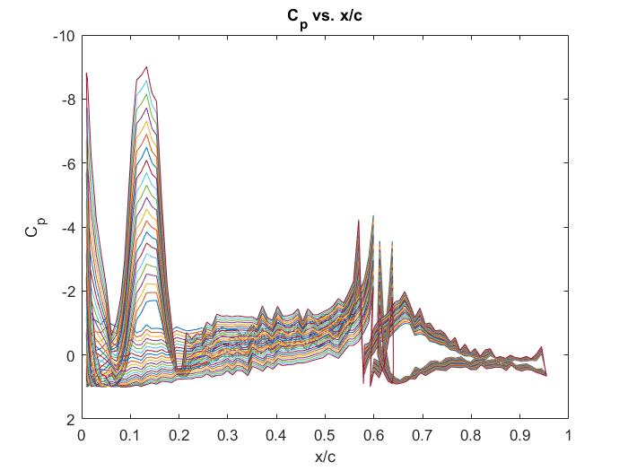

**Figure 11. Maybe Squids Don’t Fly (Squid CP vs. *x/c*).** At roughly 0.15 *x/c*, the maximum CP for angle of attack 15 was -9.0128.

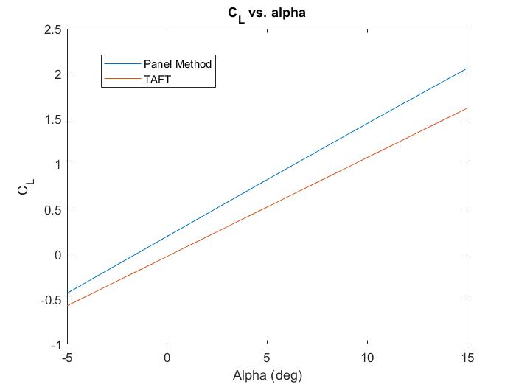

**Figure 12. Or Maybe They Do (Squid CL vs. alpha).** TAFT predicts an alpha zero-lift of 0.2 degrees for the squid, while the panel method predicts it to be -1.5 degrees. The mean variation in the CL predictions for all points was 0.2987.

1. **Observations**

The plots for the Supermarine 371-I airfoil turned out the best, with the coefficient of pressure (Fig. 4) distribution having a standard shape. It’s coefficient of lift plots (Fig. 5) for both TAFT and the Hess-Smith panel method also had the least deviation out of all the airfoils, sitting at 0.1657. This airfoil is the most symmetric one tested, which likely made the results of both methods more accurate. Coupled with the fact that it had the lowest coefficient of lift deviation, it can be assumed that the methods most precisely predicted the results of this airfoil. From this conclusion, it is therefore also probable that the methods are most accurate when testing symmetrical airfoils.

In Fig. 7 the camber line for the NASA LRN 1015 airfoil can be seen the have curvature. The deviation for this airfoils coefficient of lift plots was the greatest of the three chosen, even outdoing the squid with a mean of 0.9778 CL value. There is a gap within the coefficient of pressure plot that is likely the resultant of the camber, and the overall shape of the plot is normal, so there is nothing truly unusual about Fig. 8. The error in the lift coefficient plots again falls back to the idea that the methods are not as accurate with cambered airfoils.

Surprisingly, the variation in the CL plots for the squid is not incredibly far off, with a mean deviation of 0.2987 in the coefficient of lift values. However, the coefficient of pressure plot is anything but normal, but this was expected as a squid is an animal, not an airfoil. Squids do have an airfoil-type shape when jetting (such as in Fig. 2, of the original image), making them more hydrodynamic, which could explain why the CL variation is lower than expected.

1. **Conclusion**

The Supermarine 371-I airfoil had the cleanest results when put through the MATLAB code, and it was the most symmetrical. Both the squid and the NASA LRN 1015 airfoil had significant camber, but even though the squid’s camber varied with greater intensity it still had less-varied coefficient of lift plots. This does not however speak for the coefficient of pressure plots, as the squid CP plot shows much greater disorganization and potential for error. In conclusion, the results indicate that the Hess-Smith panel method and TAFT work best for symmetrical airfoils, and deviation begins to appear in significance when camber is introduced.

1. **Appendix**

%% Final Aero I Project: Panel Method over 2 airfoils and an animal

% Digitization software used for animal

clear all;close all;

%% Start of code

% Loading file and adjusting

% Remove name

% flipud

% Only works for semi-sign-consistent files (see flipud section, first 8 elements)

% ---------------- Change file here ---------------- %

fid = fopen('Output_edge_coordinates.txt'); % filename

% ---------------- ---------------- ---------------- %

fgetl(fid); % skip first line

rawFoil = textscan(fid,'%f %f'); % textscan it in

fclose('all');

% Flipud to get TE to LE (ONLY DO THIS IF IT IS FROM THE WEBSITE)

if sum(rawFoil{2}(1:8) < 0) <= 0 % if there is not a negative number in the first 8 elements

% (means starts bottom side)

% then it needs to be flipped upside down for panel

% method to work

x = flipud(rawFoil{1}); % x coords are first col

y = flipud(rawFoil{2}); % y coords are second

else % if not (animal, me163)

x = rawFoil{1};

y = rawFoil{2};

end

% inputs: uinf (free-stream velocity)

% alpha (angle of attack; degrees)

aalphad = -5:15; % angle of attack in deg(-5 to 15 for the assignment)

aalpha = aalphad.*pi./180.0; % degrees to radians

uinf = 1;

c = 1; % chord for coeff lift calculation

npanel = length(x) - 1; % number of panels (210 for me163, each coord vec is 211 long)

%% Provided code

figure(1) % cp plot

%c ----- import panel coordinates (x, y (1:npanel+1))

%c ----- Note: ordering must be from bottom trailing edge to top trailing edge (clockwise)

for q = 1:length(aalpha) % for the angles of attack

aalphaLoop = aalpha(q); % current angle of attack indexed

for j=1:npanel

ds(j) = sqrt((x(j+1)-x(j))^2 + (y(j+1)-y(j))^2); % panel length

tnx(j) = (x(j+1)-x(j))/ds(j); % x component of panel tangent = cos(theta_j)

tny(j) = (y(j+1)-y(j))/ds(j); % y component of panel tangent = sin(theta_j)

xnx(j) = -tny(j); % x component of panel normal

xny(j) = tnx(j); % y component of panel normal

end

%c ---- apply V dot n = 0.0 for every panel

for i=1:npanel

xi = 0.5*(x(i)+x(i+1));

yi = 0.5*(y(i)+y(i+1));

sumn = 0.0;

sumt = 0.0;

for j=1:npanel

xj = x(j);

yj = y(j);

xip = tnx(j)*(xi-xj) + tny(j)*(yi-yj); %x* location in panel coord. system

yip = -tny(j)*(xi-xj) + tnx(j)*(yi-yj); %y* location in panel coord. system

upv = 0.5/pi*(atan2(yip,xip-ds(j))-atan2(yip,xip)); %x* velocity in panel coord. system.

vpv = 0.25/pi*log(((xip-ds(j))^2 + yip^2)/(xip^2 + yip^2)); %y* velocity in panel coord. system

if (i==j)

upv = 0.5;

vpv = 0.0;

end

uv = tnx(j)*upv - tny(j)*vpv; %x component of induced velocity in Cart. system

vv = tny(j)*upv + tnx(j)*vpv; %y component of induced velocity in Cart. system

us = -vv; % x component of source velocity

vs = uv; % y component of source velocity

a(i,j) = us*xnx(i) + vs*xny(i); %matrix elements

at(i,j) = us*tnx(i) + vs*tny(i); %matrix elements storing tangential components

sumn = sumn + uv*xnx(i) + vv*xny(i);

sumt = sumt + uv*tnx(i) + vv*tny(i);

end

a(i,npanel+1) = sumn;

b(i) = -uinf*(cos(aalphaLoop)*xnx(i) + sin(aalphaLoop)*xny(i));

at(i,npanel+1) = sumt;

end

%c --- apply Kutta condition

for j=1:npanel+1

a(npanel+1,j) = at(1,j)+at(npanel,j);

end % idk if b is supposed to be in this for loop or not, as linsolve reqs same size and it fixes it

b(npanel+1) = -uinf*(cos(aalphaLoop)*(tnx(1)+tnx(npanel)) + sin(aalphaLoop)*(tny(1)+tny(npanel)));

%c ----now solve A*ss = b to get the source strengths (ss(1:npanel)) and vortex strength (ss(npanel+1))

%c Note that your matrix is (npanel+1,npanel+1)

ss = linsolve(a,b'); % wrote this bit, had to transpose b for it to properly work

%c ---- now compute tangential velocity and cp for each panel

for i=1:npanel

xi = 0.5*(x(i)+x(i+1));

yi = 0.5*(y(i)+y(i+1));

jacksum = 0.0;

for j=1:npanel+1

jacksum = jacksum + at(i,j)*ss(j);

end

vtan = jacksum + uinf*(cos(aalphaLoop)*tnx(i) + sin(aalphaLoop)*tny(i));

cp(i) = 1.0 - vtan^2/uinf^2; %Cp

end

% Coefficient of Lift Calculation

% Panel Method with ss

cl(q) = 2.*ss(end)./(c.*uinf).*sum(ds); %will have 1 cl for each alpha

% Cp plots

plot(x(1:npanel),cp'); % have to change teh axis labels as they are

% actually negative even though says positive

% exclude last coord in x

set(gca,'YDir','reverse'); % changed axis instead of changing values

hold on

end

%% TAFT cl calculation

% Need camber first

% camber = 1/2[(y/c)|up + (y/c)|low]

% add because half of the y values are negative

% need y/c divided into upper and lower coords, x/c stays same

% For uneven panel numbers

if rem(length(y),2) ~= 0 % if odd

ylow = y(1:floor(1/2*length(y)));

yup = y(ceil(1/2*length(y):end-1)); % leave out last coord

else % if even

ylow = y(1:1/2*length(y));

yup = y(1/2*length(y)+1:end);

end

ycamb = 1/2.*(yup + ylow);

% theta calculation

% theta = acos[1-2x(i)] % transformation eqns

% theta does not suffer the plotting problem, see later comments on the airfoil plot

xcamb = x(ismember(y,yup));

theta = acos(1 - 2.*xcamb);

for q = 1:length(aalpha)

alphaLoop = aalpha(q); % same setup as before for current alpha

for i = 1:(length(yup)-1) % number of panels (number of midpoints)

dfdx = (ycamb(i+1) - ycamb(i))./(xcamb(i+1) - xcamb(i));

deltaTheta = theta(i+1) - theta(i);

thetaBits = -(xcamb(i) + xcamb(i+1));

bigSum = sum(dfdx.*thetaBits.*deltaTheta);

end

clTAFT(q) = 2*pi*(alphaLoop - 1/pi.*bigSum);

end

%% Plotting

title('C_p vs. x/c')

xlabel('x/c')

ylabel('C_p')

hold off

% Airfoil Plot

figure(2) % airfoil alone plot, with camber

plot(x,y); % airfoil

title('Airfoil')

ylim([-1,1])

xlabel('x/c')

ylabel('y/c')

hold on

plot(linspace(0,max(x),length(ycamb)),ycamb,'r--'); % camber plot

%plot(xcamb,ycamb,'r--');

hold off

figure(3) % cl plot

% Panel method

plot(aalphad,cl)

hold on

% TAFT

plot(aalphad, clTAFT)

title('C_L vs. alpha');

xlabel('Alpha (deg)')

ylabel('C_L')

legend('Panel Method','TAFT');

%% Data manipulaion

clDiff = abs(clTAFT - cl); % difference in cls

clVar = mean(clDiff); % average variation in cls

% max cl

clMax = max(cl);

clTAFTMax = max(clTAFT);

% max cp

cpMax = min(cp); % final angle of attack

fclose('all');